**CBSE** **T**erm-**1** **P**ractical (**2021**-**22**)

**C**lass-**XII**

**S**ubject:- **C**omputer **S**cience **S**ubject **C**ode:- **083**

Q1. Write A Python Program To Read A Text File Line By Line And Display Each Word Separated By #.

Program Code:-

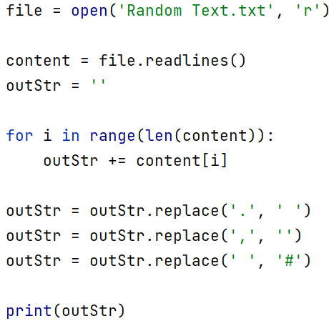

Output:-

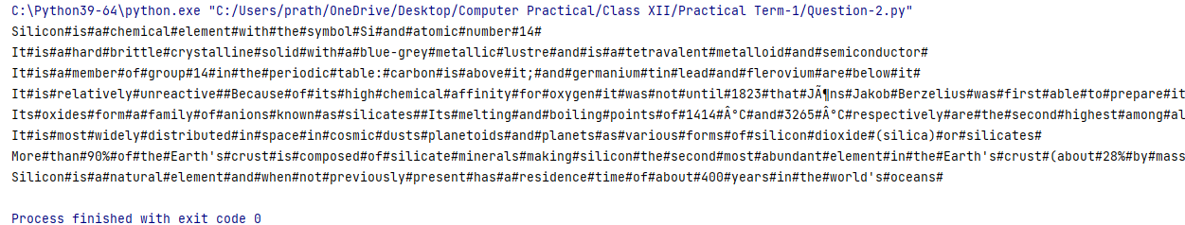

Q2. Write A Python Program To Create A CSV File By Entering User-Id And Password, Read And Search The Password For Given User-Id.

Program Code:-

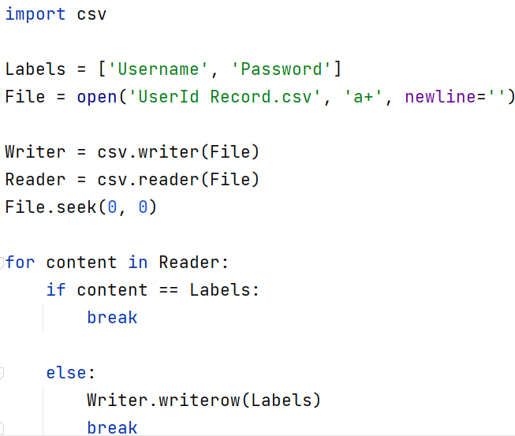

Output:-

